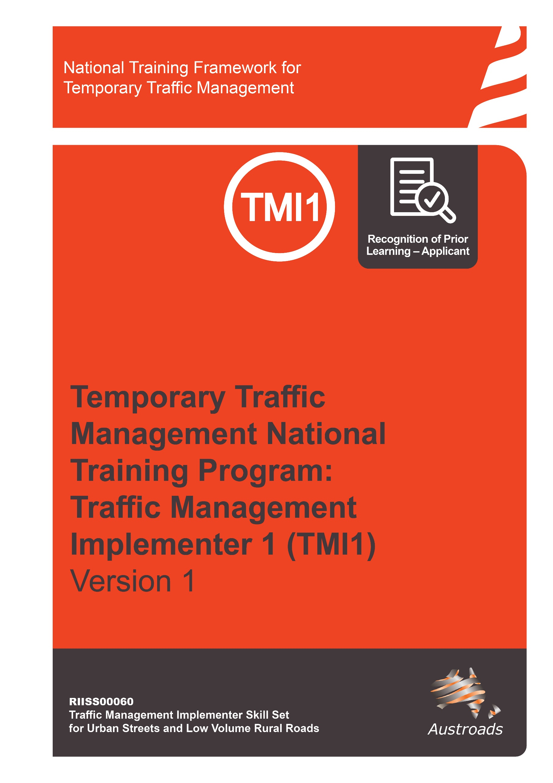

Copyright
© Austroads 2022
This work is copyright. Apart from any use as permitted under the Copyright Act 1968, no part may be reproduced by any process without the prior written permission of Austroads.
This training material has been prepared for Austroads as part of its work to improve transport outcomes in Australian and New Zealand.
The text provided in this document may not be edited.
Only an approved Training Provider is permitted to use this training resource. An Approved Training Provider is a Registered Training Organisation that has been approved by a road agency to deliver this National Temporary Traffic Management Training Program.

Version | Date | Comment
1.0 | October 2022 | Approved – Austroads Temporary Traffic Management Task Force

Contents
Copyright 2
About This Qualification 4
The RPL Application Process 5
Tips and Hints To Help You Prepare For Recognition 6
Preparing your RPL Application 6
RPL Application Form for Traffic Management Implementer TTM Category 1 (RIISS00060) 8

About This Qualification
Traffic Controllers direct the flow and speed of vehicles, and ensure the safety of drivers, pedestrians and workers. Traffic Controllers are often relied on for manual control of vehicles where automatic lights are unavailable, such as next to road works, construction sites, during public events and as part of a coordinated emergency response.
This Recognition of Prior Learning (RPL) application covers the skills and knowledge required for obtaining the RIISS00060 – Traffic Management Implementer – Urban Streets and Low Volume Roads skill set (Traffic Management Implementer 1). This skills set has been created to align to the requirements of individuals responsible for traffic management implementation on a site and road workers under their direction, as described in the Austroads Guide to Temporary Traffic Management on Temporary Traffic Management Category 1 environments. For further information visit Temporary Traffic Management | Austroads.
This RPL application covers the content of all units within the RIISS00060 – Traffic Management Implementer – Urban Streets and Low Volume Roads skill set which are;

- RIICOM201E Communicate in the workplace
This unit describes the skills and knowledge required to communicate in the workplace in the resources and infrastructure industries and other industries with relevant work practices and procedures. It applies to those working in operational roles. They generally work under supervision to undertake a prescribed range of functions involving known routines and procedures and take some responsibility for the quality of own work outcomes.

- RIIRIS301E Apply risk management processes
This unit describes the skills and knowledge required to apply risk management processes in the mining, drilling and civil infrastructure industry. This unit applies to individuals who contribute to applying risk management processes as part of their responsibilities. This could be an employer, line manager, supervisor, safety representative or employee. This unit applies to those who conduct or assist in conducting risk assessment in the workplace.

- RIIWHS302E Implement traffic management plans
This unit describes the skills and knowledge required to set out, monitor and close down traffic management plans and traffic guidance schemes in civil construction. It applies to those working in supervisory roles. They generally work in teams in live traffic environments and hold some responsibility for the outcomes of others.

- RIIWHS303 Position, set-up, and program portable traffic control devices
This unit describes the skills and knowledge required to transport, position, operate, commission and de-commission portable traffic control devices in the civil construction industry. It applies to those working in operational roles. They generally work in teams in live traffic environments under some degree of supervision.

The RPL Application Process
- Initial discussion with your assessor, this is to answer any questions you may have about the RPL process and for the assessor to determine if you are eligible to apply for RPL.
- Locate evidence of your workplace (practical) experience and formal/informal training.
- Complete and submit the RPL Application form.
- Your assessor will review your application and evidence and, if required, will call you to clarify/discuss further.
- Your assessor will organise for you to meet with them to have a conversation throughout which your assessor will ask questions to gain an understanding of you your workplace experience and knowledge.
- Completion of a written challenge test.

Tips and Hints To Help You Prepare For Recognition
To have your skills and knowledge formally recognised in the national system, assessors must make sure you have the current skills and knowledge to meet the industry standard. This means you must be involved in a careful and comprehensive process that covers the content of all units you can be recognised for.
Your RPL application will be based on providing evidence that you have the skills and knowledge required for units listed on page 4 and that you are (or have in the previous 12 months) worked as a Traffic Implementer 1 (on a live category 1 road environment) which includes meeting both the practical and theoretical components of all the units and skill set.
Here are some tips and hints for you:
- Be prepared to talk about your job roles and work history. Have an up-to-date resume or, at the least, jot down a few points about where you have worked, either paid or unpaid, and what you did there.
- Locate your current position description and any performance appraisals (if available).
- Consider a third party referee – that is someone in your current and/or previous workplace that would be happy to verify your skills and you are comfortable with them discussing this with an assessor. Remember referees need to be a current or recent (from the past 12 months) supervisor/ team leader.
You may also have community contacts from volunteer work that can vouch for your skills.
- Collect any certificates from in-house or formal training you have successfully completed.
- Other forms of evidence could include letters from employers, records of your professional development sessions, employers or clients in related industries or government agencies, acknowledgements, workplace forms or other relevant documents.

Preparing your RPL Application
Complete the RPL Application form noting any evidence you will require.
Step 1 Collect Evidence
Documents you may provide to support your application include:
Workplace documents
- Any licences/tickets/authorisations
- Resume or details of work history
- certificates from in-house or formal training courses completed.
- Diaries/task sheets/job sheets/log books
- Site training records
- Site competencies held record
- references/letters from current and/or previous employers/supervisors
Remember you will need to supply contact details of one or two work referees (third party) who can confirm your skills.

Step 2 Submit the evidence and application
- Collect the evidence you need to support your application
- Remember, you are signing a declaration stating that the information you provide, including any copies of documents or licenses you are supplying as evidence, is authentic.
Step 3 Assessor to check
The assessor will check the evidence you have provided and if required contact you by phone or email to clarify anything unclear or missing.
Step 4 Conversation with Assessor
The conversation provides an opportunity for you to confirm your skills and experience identified in your RPL application. This will also confirm your industry currency and understanding of the Austroads Guide to Temporary Traffic Management, Australian Standards and jurisdictional specific standards.
Step 5 Completion of Challenge Test
You will be given a date/time by your Approved Training Provider to complete a challenge test.
Step 5 Notification
The ATP will contact you to discuss the outcome of your RPL application.

RPL Application Form for Traffic Management Implementer
TTM Category 1 (RIISS00060)

1 Personal Details
Surname: | Title: Mr/Mrs/Ms/Miss/Dr/n/a
First Name: | Middle Name(s):
Date of Birth:
Home Address:
Suburb: | Postcode
Postal Address (if different from above)
Suburb: | Postcode
Phone Number: | Work Phone:
Email:
2. Current Employment
Are you currently employed? ☐ Yes ☐ No
If yes, is your occupation related to the qualification you are seeking RPL for? ☐ Yes ☐ No
What is the name of your employer?
Please provide details of the workplace:
Name:
Address:
Type of workplace (profession):

3. Formal Training / Qualifications
Have you completed any nationally recognised training related to industry? ☐ Yes ☐No
Name of course or qualification | Completion date (month, year) | Country | Name of Training Organisation

4. Other Training/Certificates Completed (non-accredited)
Name of course or qualification | Completion date (month, year) | Country | Name of Training Organisation

Workplace Validation  Complete the column marked A (applicant) by placing a tick or a cross to show if you can address the requirement (tick = yes, cross = no). |  | A | V
1 | Participated in pre-start meetings including accessed and reviewed the content of the job pack, including Traffic Management Plan (TMP), Traffic Guidance Scheme (TGS) and identified work site requirements
3 | Accessed and checked the functionality of two-way radios
5 | Confirmed the TMP and TGS was suitable for the site conditions, work activities, and conditions, including:
5 | - environment suitable
5 | - signage sequence
 | - site suitable
 | - traffic volume as per TGS
4 | Accessed and placed the correct signage in the correct location in accordance with the TGS.
5 | Reviewed the residual risk from TMP and identified, addressed and reported potential risks, hazards and environmental issues and determined control measures
6 | Use mathematical and planning skills to identify and confirm the availability of all necessary resources, including:  - Number of personnel required and qualifications  - Vehicle and equipment  - Managing fatigue and breaks
7 | Provide clear, concise and timely face to face instructions to Traffic Control personnel on TGS set up and TC station positioning, clarifying, and confirming understanding, when needed.
8 | Confirm traffic management plan is implemented correctly and report to supervisor in charge of site so roadwork crew can begin activities

Workplace Validation  Complete the column marked A (applicant) by placing a tick or a cross to show if you can address the requirement (tick = yes, cross = no). |  | A | V
9 | Close of site - direct and provide clear and concise instructions to personnel removing signs and devices as per the TGS and manufacturers specifications
10 | Ensure cleaning, checking maintaining and storage of tools and equipment, to meet manufacturers specifications, at the completion of the task

6. Evidence Table
When you collect your evidence, write what the evidence is in the ‘attached evidence table’ and align the line number on the first table with the letter which corresponds to the evidence you are providing. Remember, you are signing a declaration stating that the information you provide, including any copies of documents or licenses etc. you are supplying as evidence, is authentic.  Attached evidence table (add lines as required) |  | What numbered row/s does this align to in the table above?
A
B
C
D
E
F
G
H

Third Party Declaration
Who should complete this tool?
This tool is to be completed by someone who is currently working or has previously worked (within the last 12 months), in a supervisory capacity to the applicant and can confirm their skills and knowledge as relevant to workplace performance.

What do I have to do?
Complete the Referee Testimonial on the next page.

How are my comments used in the assessment decision?
There are no right or wrong answers. It is your perception or opinion that is important. You are not providing the assessment decision; however, your comments will assist the assessor in forming their final opinion of the applicant’s competence. The applicant will provide a range of evidence to help the assessor make the final decision.

1 Third Party Declaration - Personal Details
Name:
Position Title:
Organisation:
Suburb: | Postcode:
Phone Number: | Work Phone:
Email:
Length of time you have worked with the applicant
☐ Less than 1 year ☐ 1–2 years ☐ 2–5 years ☐ More than 5 years

TICK THE SKILLS THE APPLICANT HAS SUCCESSFULLY COMPLETED IN THE WORKPLACE
1 | Arrived for work fit for duty (has own PPE, not tired, not impaired by alcohol or drugs).  Attended pre-start or handover meetings | ☐
2 | Accessed and reviewed the content of the job pack, including Traffic Management Plan (TMP), Traffic Guidance Scheme (TGS) and identified work site requirements, including: | ☐
2 | - type of work | ☐
2 | - start/finish time | ☐
2 | - emergency procedures | ☐
2 | - safe working and environmental – SWMS/JSEA | ☐
2 | - permit requirements | ☐
2 | - communication systems | ☐
2 | - qualified personnel and resources – type and number | ☐
2 | - site specific safety documents, including risk assessment and residual risk register | ☐
2 | - signage sequence | ☐
2 | - equipment requirements | ☐
2 | - legal requirements | ☐
3 | Confirmed the TMP and TGS was suitable for the site conditions, work activities, and conditions, including:
 | - environment suitable | ☐
 | - signage sequence | ☐
 | - site suitable | ☐
 | - traffic volume as per TGS | ☐
4 | Contacted the Traffic Management Designer/Supervisor if they needed clarification on TMP/TGS implementation. | ☐
5 | Reviewed the residual risk from TMP and identified, addressed and reported potential risks, hazards and environmental issues and determined control measures including
 | - involving others in risk | ☐
 | - documenting risk process | ☐
 | - gaining approval where necessary to implement | ☐
 | - escape path | ☐
 | - vulnerable road users | ☐
 | Able to explain how to identify if risk is acceptable or unacceptable | ☐

TICK THE SKILLS THE APPLICANT HAS SUCCESSFULLY COMPLETED IN THE WORKPLACE
6 | Use mathematical and planning skills to identify and confirm the availability of all necessary resources, including: | ☐
 | - number of personnel required and qualifications | ☐
 | - vehicle and equipment | ☐
 | - managing fatigue and breaks | ☐
 | - signs, devices and PTCD | ☐
7 | Provide clear, concise and timely face to face instructions to Traffic Control personnel on TGS set up and TC station positioning, clarifying, and confirming understanding, when needed including
 | - task and reporting requirements | ☐
 | - radio communications | ☐
 | - emergency procedures | ☐
 | - equipment checks and requirements | ☐
 | - PTCD requirements, if applicable | ☐
 | - Traffic Controller tasks | ☐
 | - Traffic Controller location | ☐
8 | Apply safe manual handling procedures for self and others, when lifting, pushing, pulling, holding, throwing and/or carrying equipment. | ☐
9 | Check signs and devices are positioned and installed correctly, and documents completed including signs and devices being: | ☐
 | - PTCD and TC locations | ☐
 | - PTCD is set up and programmed according to the TGS | ☐
10 | Check and confirm pedestrian pathways and signs and devices are positioned and installed correctly and are safe for use including:
 | - pathway is clear of slip or trip hazards | ☐
 | - cables and hoses clear of pathways or appropriately covered | ☐
 | - walk through of pedestrian control measures | ☐
11 | Coordinate/conduct any adjustments of signage or devices within tolerances and their role including:
 | - ensure can be clearly seen by road users | ☐
 | - State/Territory requirements | ☐
12 | Confirm traffic management plan is implemented correctly and report to supervisor in charge of site so roadwork crew can begin activities.
 | - Contact the TMD if modifications were required to the TGS including: | ☐
 | - clearly communicate issue/s with TMD | ☐

TICK THE SKILLS THE APPLICANT HAS SUCCESSFULLY COMPLETED IN THE WORKPLACE
 | - coordinate/conduct modification if authorised | ☐
 | - document discussion and outcomes (noted on TGS) | ☐
13 | Maintain traffic flow by moving signage within tolerances / approved modifications, due to traffic management crew reports and site observations when and if required. | ☐
14 | Close of site: Direct and provide clear and concise instructions to personnel removing signs and devices as per the TGS and manufacturers specifications to ensure: | ☐
 | - correct sequence | ☐
 | - regulatory signs uncovered, where required | ☐
 | - cover signs if unattended site | ☐
 | - removed signs, where required | ☐
 | - PTCD auto program, if necessary | ☐
 | - remediation conducted if necessary | ☐
 | - clarifying and confirming understanding, when needed | ☐
 | - confirms roadway safe for public/vehicle usage | ☐
 | - drive/walk through inspection | ☐
 | - use appropriate short term low impact work methods for sign and device removal | ☐
15 | Ensure cleaning, checking maintaining and storage of tools and equipment, to meet manufacturers specifications, at the completion of the task including:
 | - UHF radio, checked and charged | ☐
 | - PTCD | ☐
 | - ensure the work area is appropriately cleared and no signage and devices are left behind | ☐
 | - remove and clean sign/s if site is finished | ☐
 | - remove personal rubbish and other environmental impacts, if necessary. | ☐
 | - document and report damaged and faulty equipment | ☐

I certify that (add name of applicant) has undertaken the activities as ticked above.
If you would like any further information please feel free to contact me.

Signature
Print Name and Position
Company

Applicant Declaration
The information I have provided is true and correct. The evidence to support my claims is authentic.
Applicant name (print) _______________________________________
Applicant signature _________________________________________
Applicant contact phone _____________________________________

Please return this application form with relevant evidence to:

ATP to enter contact details

Your ATP will review your application and contact you:
- Date/times for competency conversation and completion of challenge test

